
Course: Cloud Computing
Instructor: Sir Tariq Gouri
Name: Yasir Hussain(2280167)
Program: BSSE-7B
Final Labs
LAB-02

Task01: Implement Management Groups.
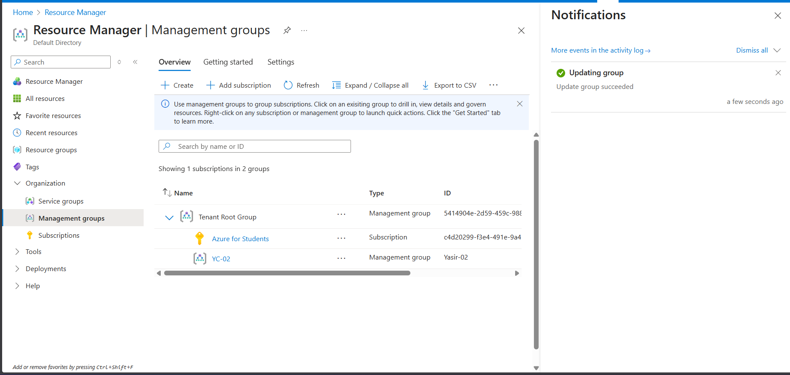

Task02: Review and assign a Built-in Azure Role.
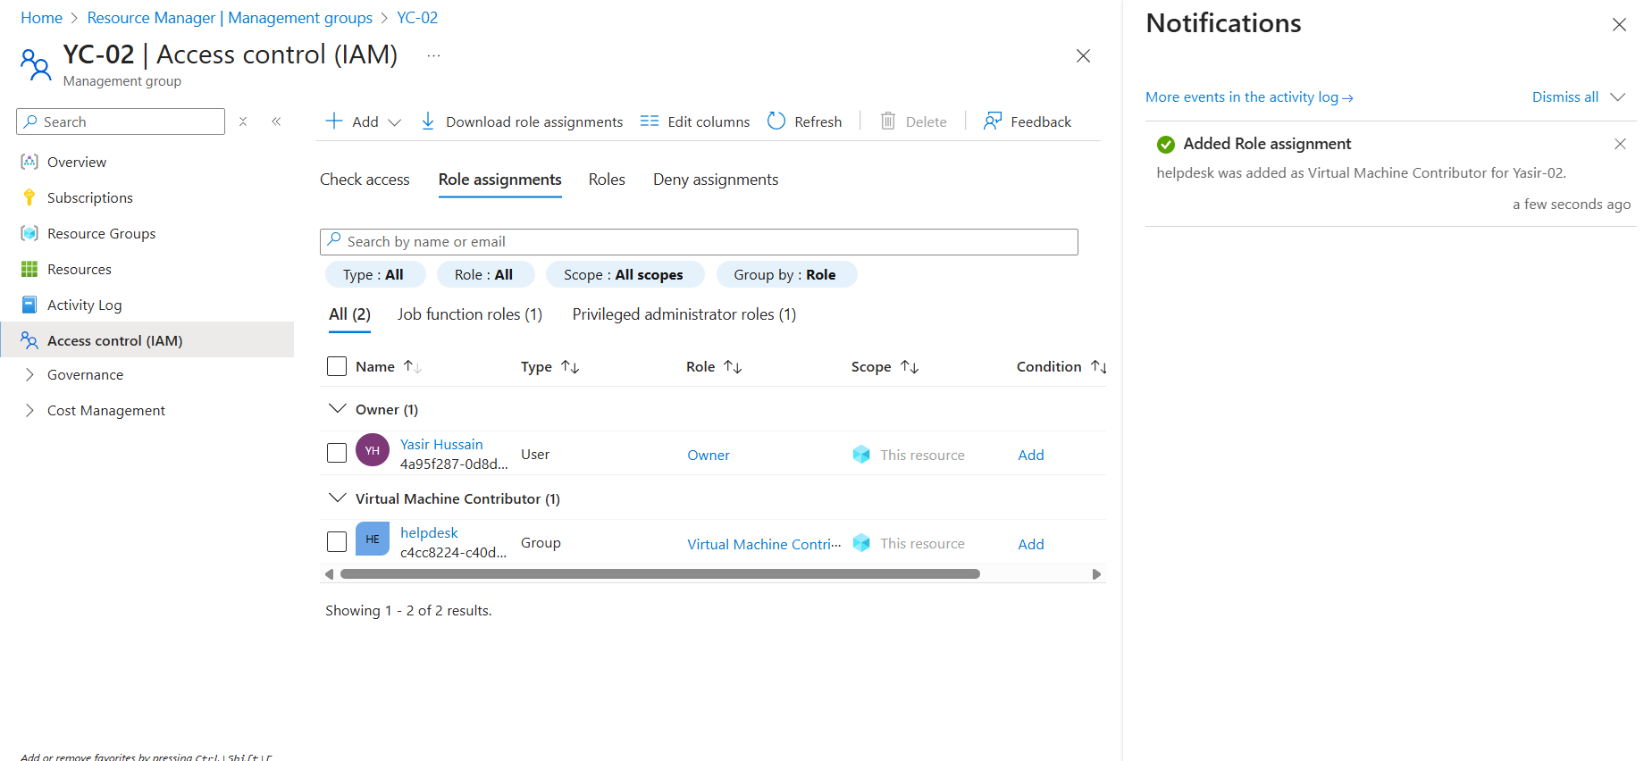
Task03: Create a Custom RBAC Role.
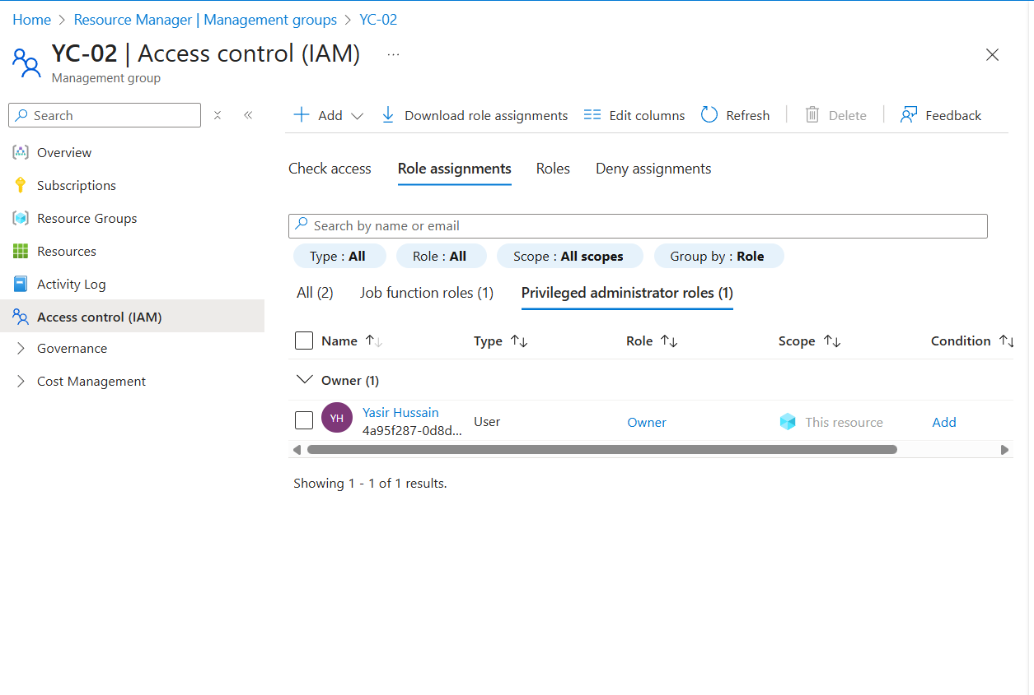

Task04: Monitor Role Assignments.
